**DAILY ONLINE ACTIVITIES SUMMARY**

|  |  |  |  |  |  |  |  |
| --- | --- | --- | --- | --- | --- | --- | --- |
| **Date:** | **26-06-2020** | | | | **Name:** | **Niharika G V** | |
| **Sem & Sec** | **8th sem, A sec** | | | | **USN:** | **4AL16CS09** | |
| **Online Test Summary** | | | | | | | |
| **Subject** | | **No Test Conducted** | | | | | |
| **Max. Marks** | |  | | **Score** | |  | |
| **Certification Course Summary** | | | | | | | |
| **Course** | **Introduction to Cyber Security** | | | | | | |
| **Certificate Provider** | | | **Great Learning** | **Duration** | | | **5.5Hr** |
| **Coding Challenges** | | | | | | | |
| **Problem Statement: Multiply two matrices** | | | | | | | |
| **Status: Completed** | | | | | | | |
| **Uploaded the report in Github** | | | | **Yes** | | | |
| **If yes Repository name** | | | | **Daily Progress** | | | |
| **Uploaded the report in slack** | | | | **Yes** | | | |

Online Test Details: **No Test Conducted**

Certification Course Details:

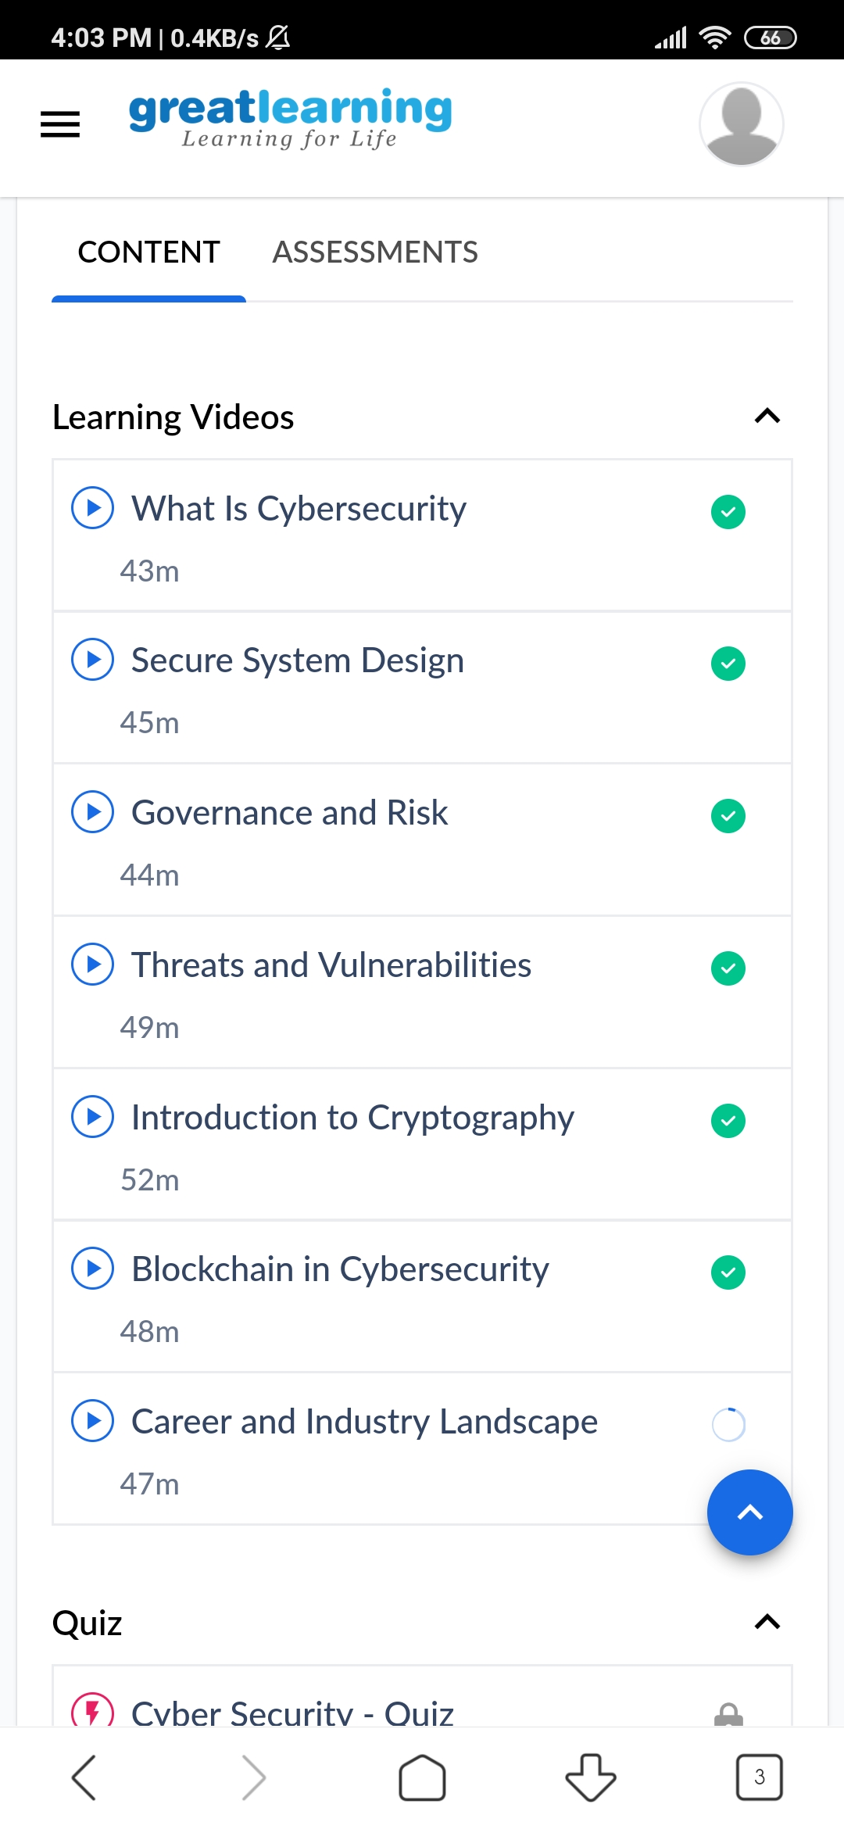

Coding Challenges Details:

package com.beginnersbook;

import java.util.Scanner;

public class JavaExample

{

public static void main(String args[])

{

int num, temp, digit, count = 0;

Scanner scanner = new Scanner(System.in);

System.out.print("Enter any number:");

num = scanner.nextInt();

scanner.close();

temp = num;

while(num > 0)

{

num = num / 10;

count++;

}

while(temp > 0)

{

digit = temp % 10;

System.out.println("Digit at place "+count+" is: "+digit);

temp = temp / 10;

count--;

}

}

}